**ASSIGNMENT 17 & 18**

Nama : Julio Andarestu

Institusi : Universitas Sriwijaya

Mentor : Erwin Fernanda

**Latihan :**

1. From the customers table,  
   Select column FirstName, LastName, Address, State  
   where the FirstName column must be displayed in an alphabetical order,  
   and the State column does not contain Null.
2. From the customers table,  
   Take the information from 5 customers who are in the country USA. The information that needs to   
   be taken is only the CustomerId, telephone number (phone) and email address.
3. From the invoices table,  
   retrieve information CustomerId, InvoiceDate, Total for transactions with Total above 10,  
   and sort the Total values from the largest.

**Jawaban :**

**Struktur Database**

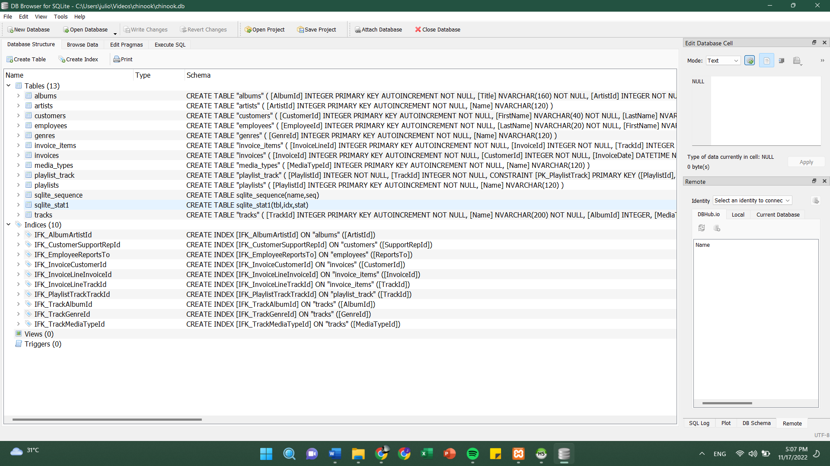

**Eksekusi SQL**

1. Output :

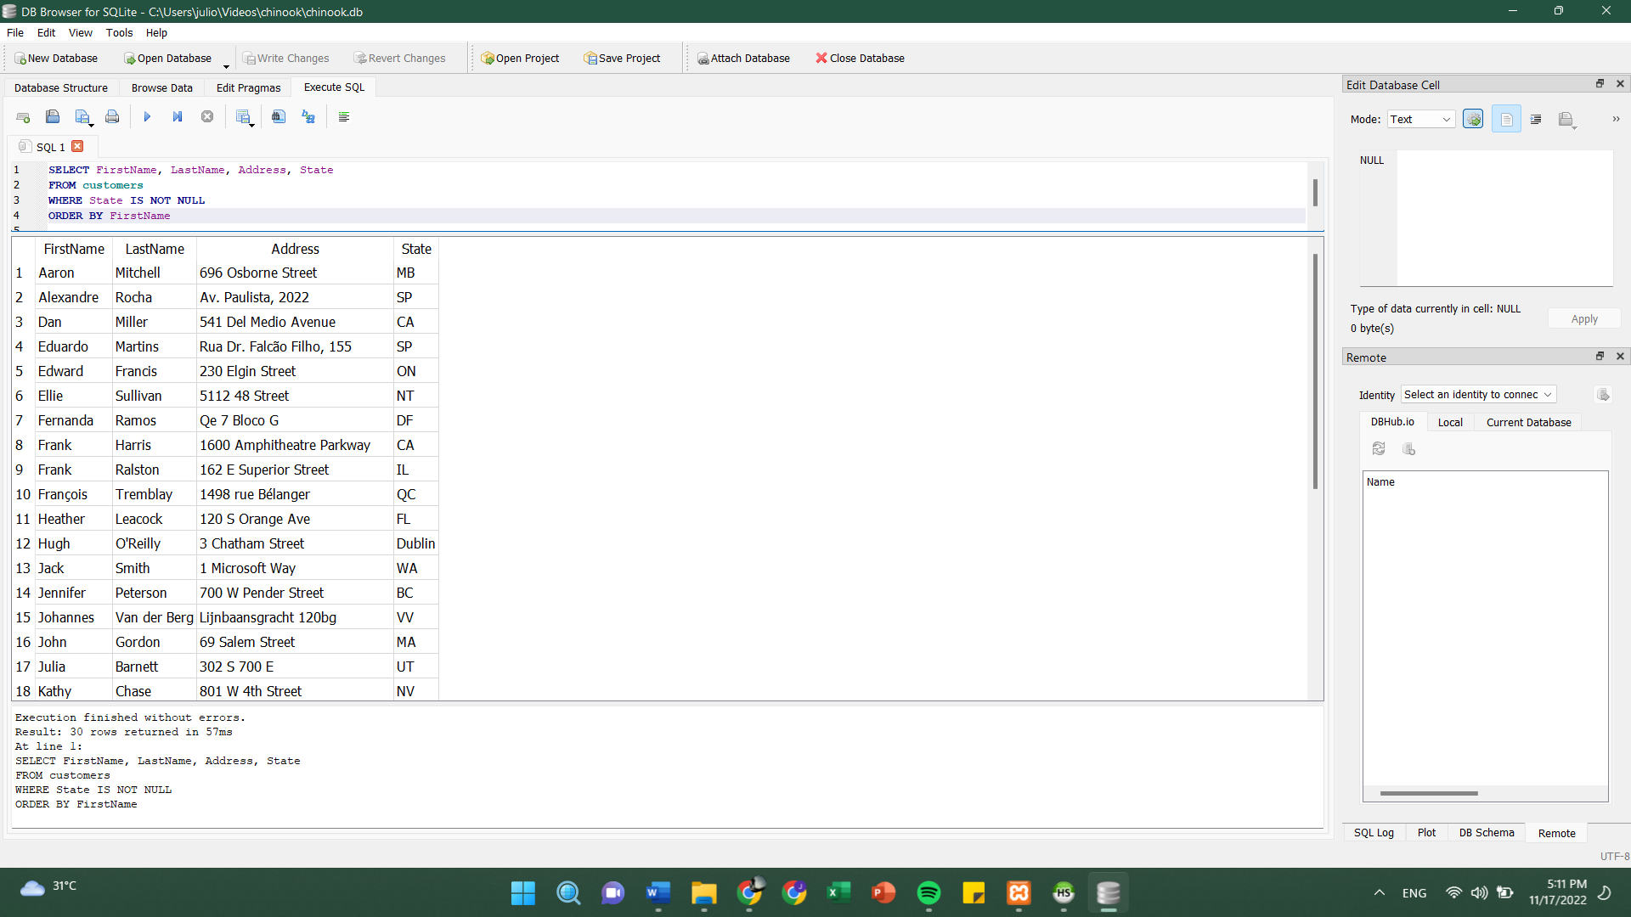

Query :

SELECT FirstName, LastName, Address, State

FROM customers

WHERE State IS NOT NULL

ORDER BY FirstName

1. Output :

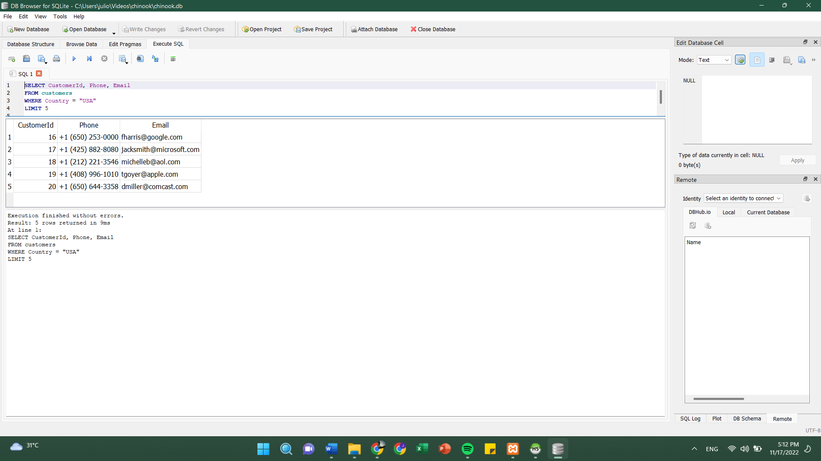

Query :

SELECT CustomerId, Phone, Email

FROM customers

WHERE Country = "USA"

LIMIT 5

1. Output :

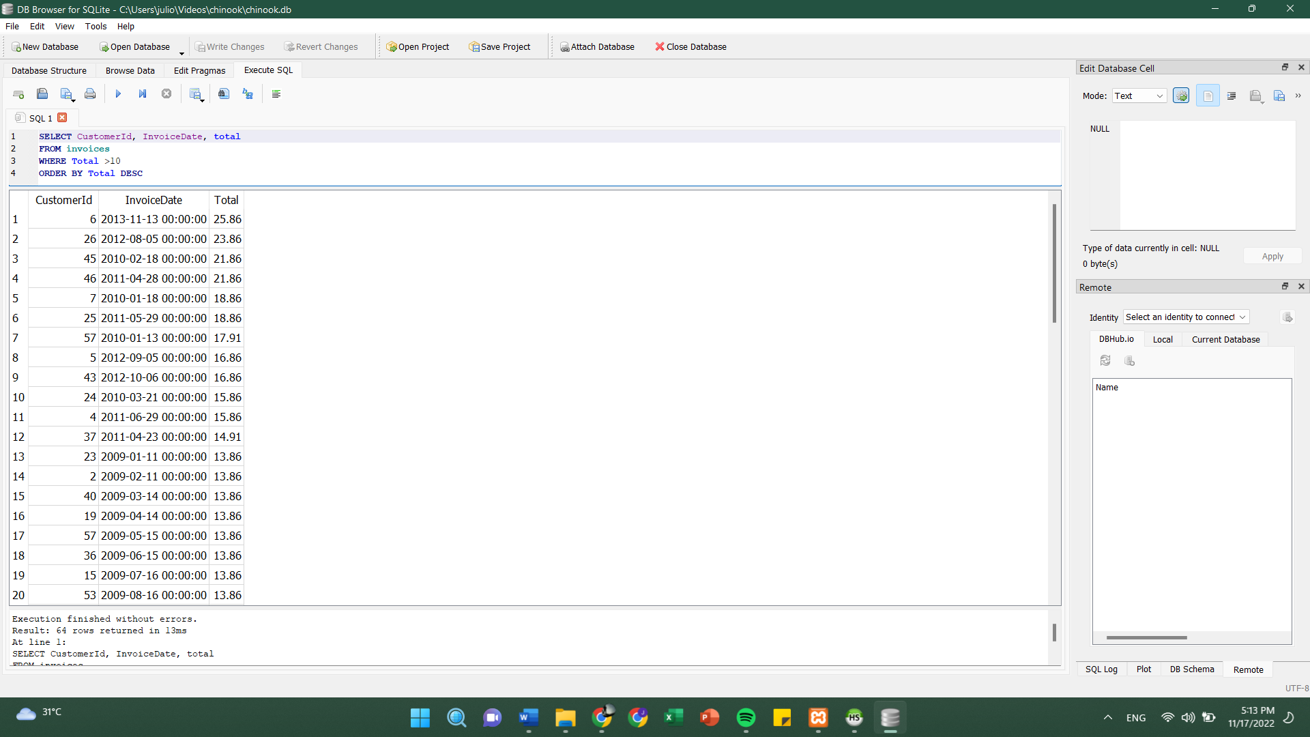

Query :

SELECT CustomerId, InvoiceDate, total

FROM invoices

WHERE Total >10

ORDER BY Total DESC